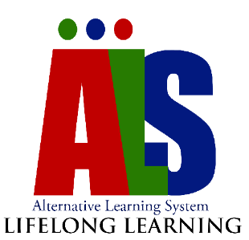
Republic of the Philippines
Department of Education
Negros Island Region
SCHOOLS DIVISION OF NEGROS ORIENTAL
ALTERNATIVE LEARNING SYSTEM
Dumaguete City

TRACKING FORM FOR ALTERNATIVE LEARNING SYSTEM LEARNERS

Name of Learner | Address of CLC | Program (BLP/Elm/Sec) | No. of Days Absent | Reasons for not Attending | Interventions | Remarks

Prepared by: Noted by:
DALSC/MT/AGAP/ABOT ALAM Implementer School Head

